# Calibrating the CJC value

## Method:

Firstly the CJC value should never be negative, so always have a Start Value of zero. The CJC value should also never exceed 0.0782 so this would be a good End Value also. Finally the number of values then provides the resolution of accuracy desired but also impacts how many FPGA resources will be used by the Look Up Table.

Open the attached VI and run with the default given values if desired or enter user specified values:

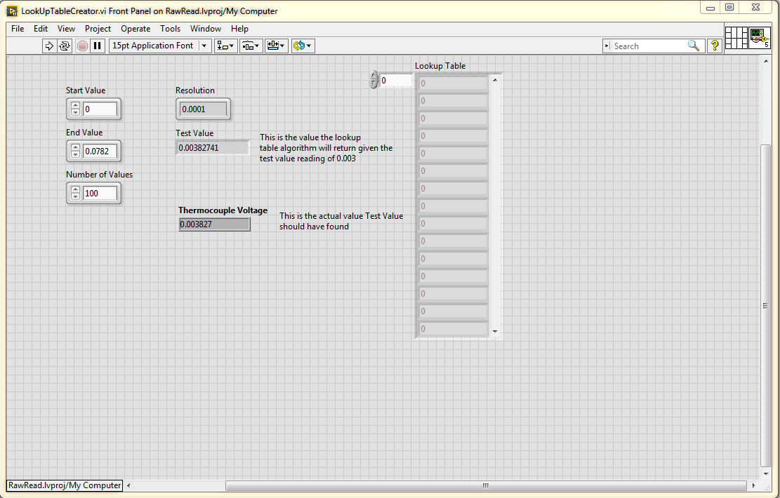

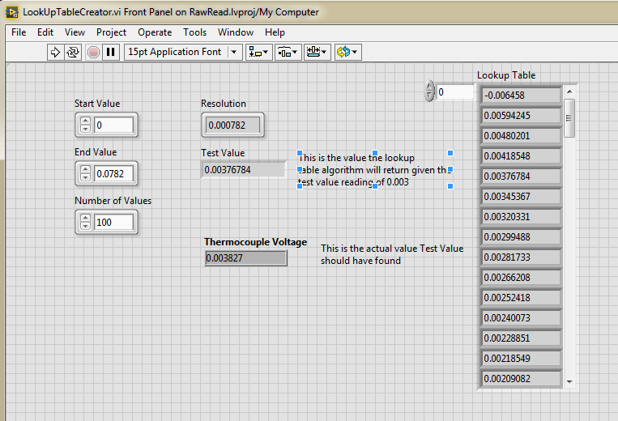

Now with populated values in the array, create a new FPGA VI, open the block diagram of the LookUpTableCreator.vi and drag and drop the Lookup Table indicator on the new VI as given below:

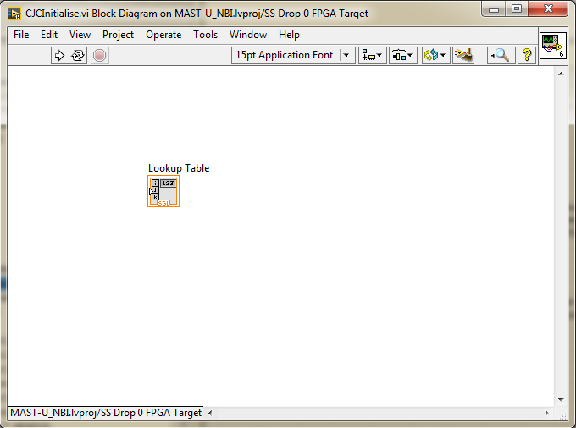

Change the indicator to a control and create a new indicator for this control to wire too:

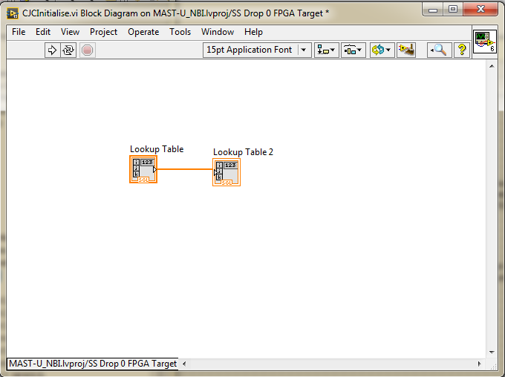

You must then rename the indicator to Init Data Out and connect this terminal to the connector pane as given below:

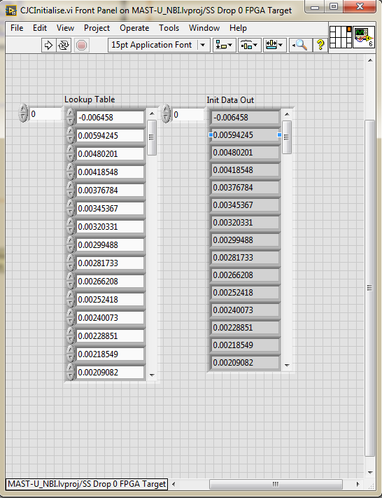

Make sure to make the current values now default for the Lookup Table indicator.

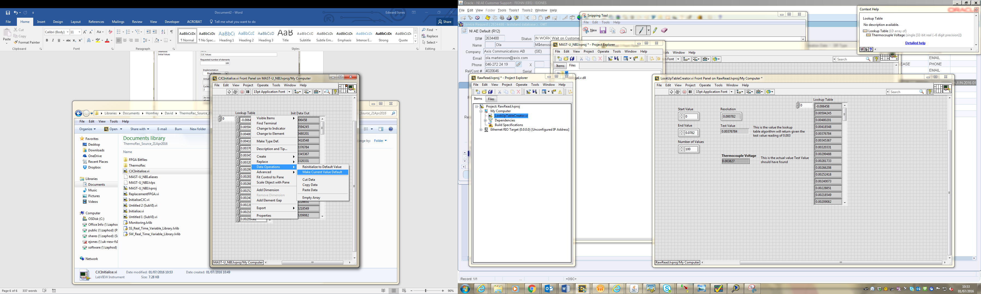

Now select in the FPGA Target to create a new block memory:

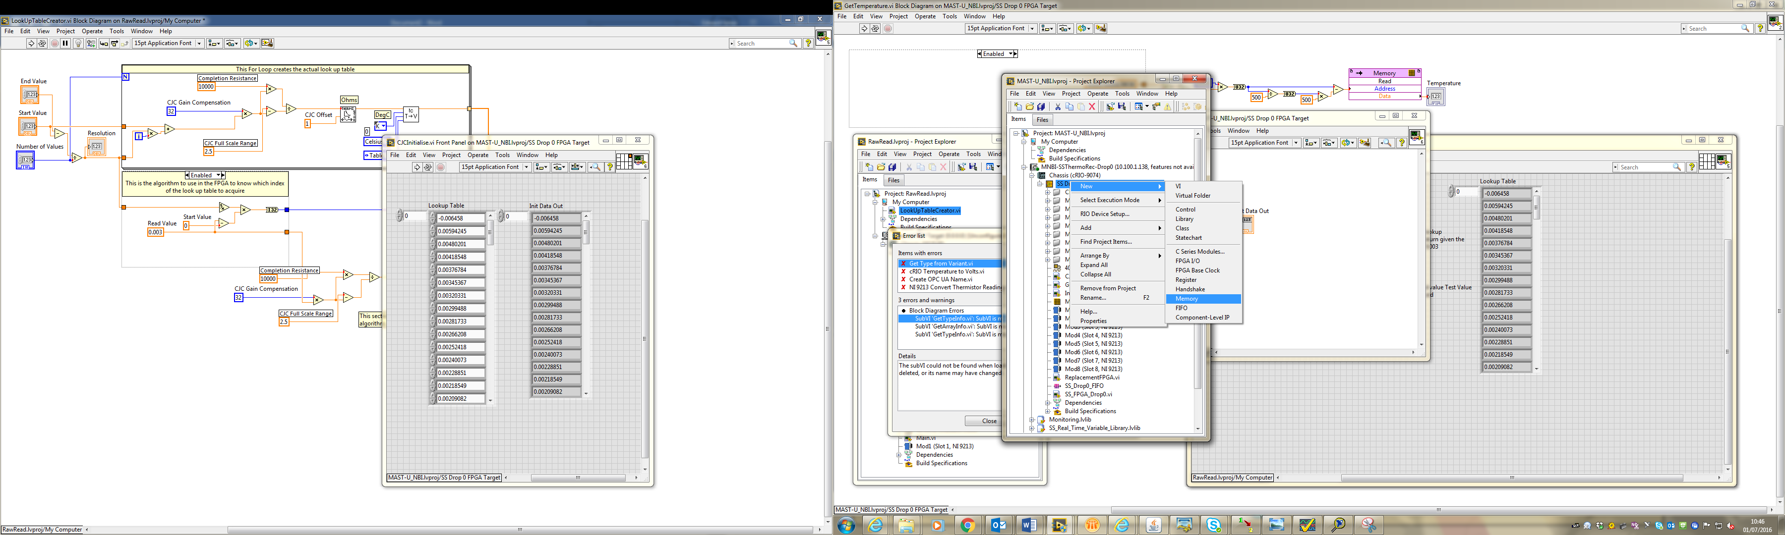

Set the number of elements to the previously set number of values in the LookUpTableCreator VI and appropriately name the memory, cycles of read latency is not an issue since the acquisition rate is quite low.

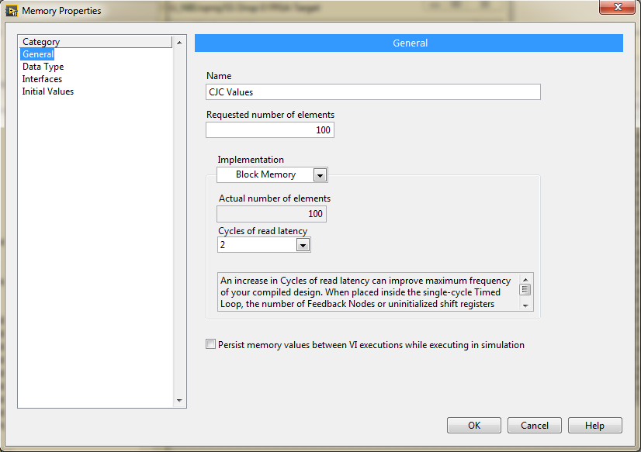

Set the data type to Single so as to not lose any precision:

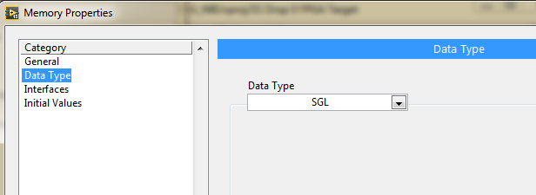

Now select under Initial Values the Initialization Method to be an Initialization VI, then select the VI that we have created and then select Run VI to plot the values:

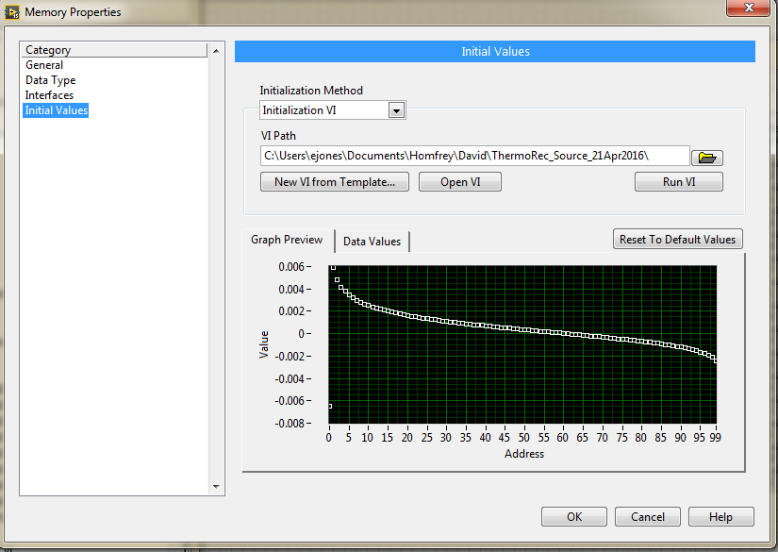

Repeat the steps to create block memory on the Ethernet RIO as well as the CompactRIO.

Now Copy the look up algorithm from the LookUpTableCreator and place this into the enabled diagram in the GetTemperature VI, uses this algorithm to acquire the address to look up into memory. Additionally copy the Resolution to the VI also and then convert this to a constant value:

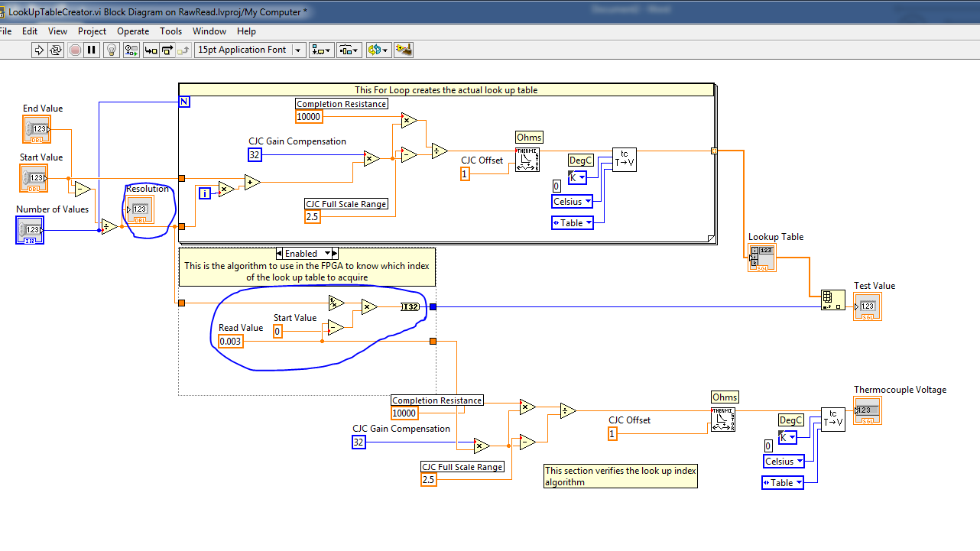

Then add the CJC Control which will be input when the VI is called and connect this terminal to the connector pane. Additionally, then implement the Memory Read and ensure the CJC Control data type is a fixed point, 25 bits long with a word length of -2.

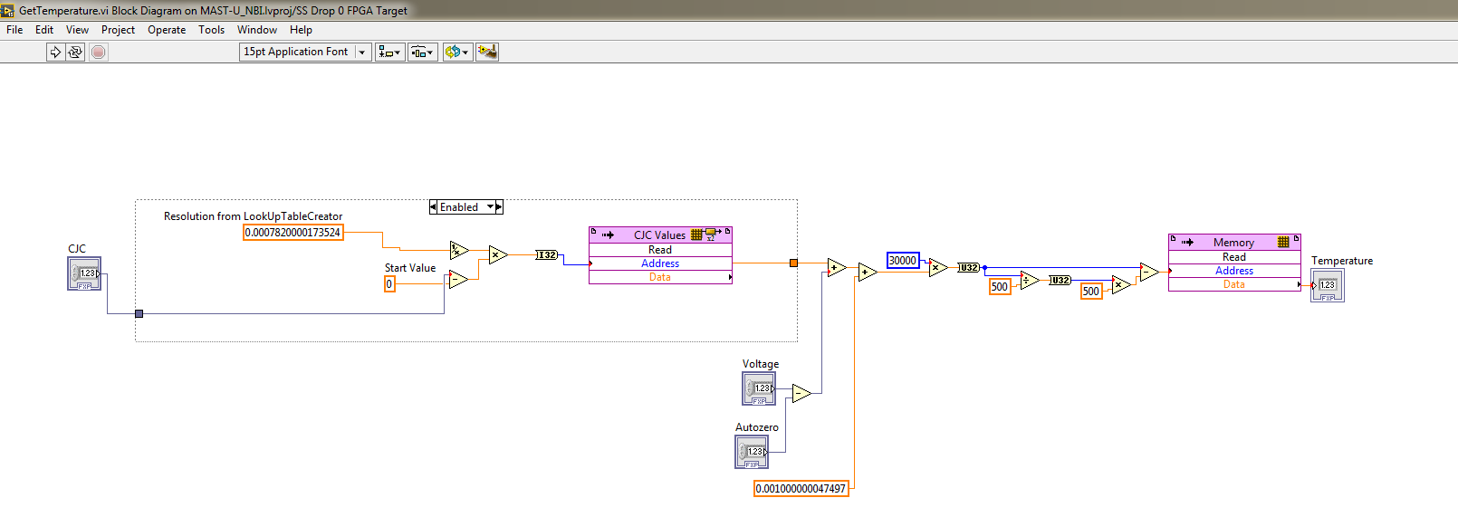

An Implementation of Look Up Tables has now been incorporated and should provide a robust methodology of converting the CJC readings to the voltage offset that these cause.